WEEK 4
Week Ending: 26-09-2025 | DAY: |  | Subject: Computing
Duration: 50mins |  |  | Strand: Introduction To Computing
Class: B8 | Class Size: |  | Sub Strand: File Management Techniques
Content Standard:  B8.1.1.2. Demonstrate the use of the Desktop features. |  | Indicator:  B8.1.1.2.1 Explore the use of the Charms bar |  |  |  | Lesson:  1 of 2
Performance Indicator:  Learners can explore the use of the Charms bar |  |  |  | Core Competencies:  Communication and Collaboration, Critical Thinking and Problem solving
Reference: Computing Curriculum P.g. 24
Activities For Learning & Assessment |  |  |  |  | Resources |  | Progression
Starter (5mins)  Revise with learners to review their understanding in the previous lesson.  Share performance indicators and introduce the lesson.  Main (35mins)  Using pictures and charts, guide learners to identify and describe what a charms bar is.  A charm bar is a universal toolbar in the windows 8 operating system that can be accessed from anywhere no matter what you are doing or what application you are running.  In groups, have learners explore the options on the charms bar.  When activated, the charms bar contains 5 different buttons;  - Search  - Share  - Start  - Devices  - Settings  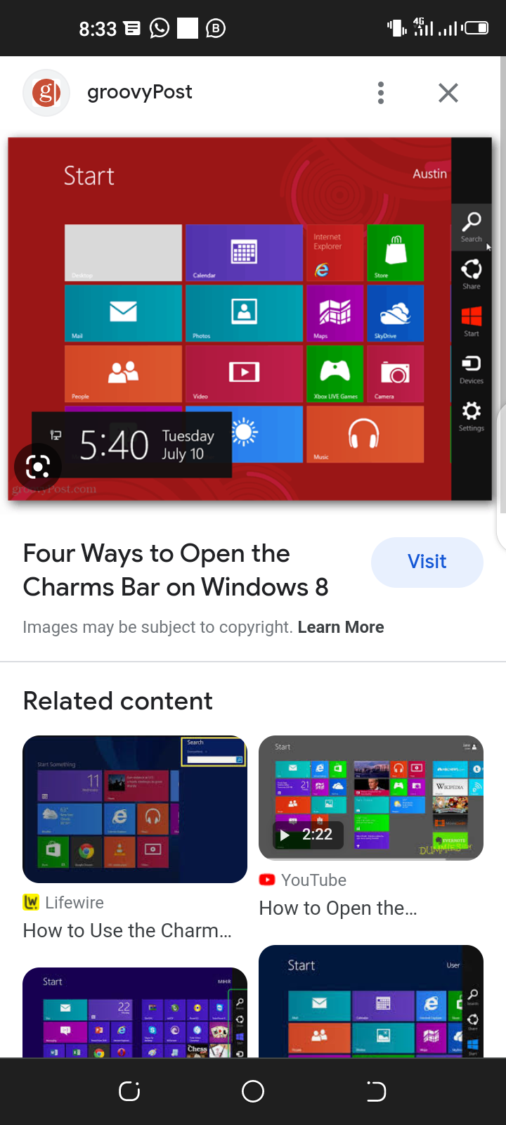  Engage learners to identify the icons in the Charms bar  Guide learners to describe features of the Charms bar icons.  Assessment  What is a charms bar?  Identify and explain the options on the charms bar?  Name any five icons on the charms bar.  Reflection (10mins)  Use peer discussion and effective questioning to find out from learners what they have learnt during the lesson.  Take feedback from learners and summarize the lesson. |  |  |  |  | Pictures and videos |  | Exploring the use and features of the Charms bar

Week Ending: 26-09-2025 | DAY: |  | Subject: Computing
Duration: 50mins |  |  | Strand: Introduction To Computing
Class: B8 | Class Size: |  | Sub Strand: File Management Techniques
Content Standard:  B8.1.1.2. Demonstrate the use of the Desktop features. |  | Indicator:  B8.1.1.2.2. Practice file management techniques (Drive Management) |  |  |  |  | Lesson:  1 of 2
Performance Indicator:  Learners can demonstrate file management techniques |  |  |  | Core Competencies:  Communication and Collaboration, Critical Thinking and Problem solving
Reference: Computing Curriculum P.g. 25
Activities For Learning & Assessment |  |  |  |  | Resources | Progression
Starter (5mins)  Revise with learners to review their understanding in the previous lesson.  Share performance indicators and introduce the lesson.  Main (35mins)  Brainstorm learners to explain key terms in the lesson.  - Disk defragmentation – is the process of reorganizing the data stored on the hard drive so that related pieces of data are put back together.  - File compression – is a data compression method in which the logical size of a file is reduced to save disk space for easier and faster transmission over a network or the internet.  - Disk Partitioning – is the creation of one or more regions on secondary storage, so that each region can be managed separately.  Demonstrate the file management techniques such as defragmentation, compression of files, etc.  Engage learners to explore ways of partitioning a hard disk.  Guide learners to discuss the advantages and disadvantages of compressing files and disk defragmentation.  Assessment  1. Define the following;  i. Disk defragmentation ii. File compression iii. Disk partitioning  2. State three advantages and disadvantages of compressing files  Reflection (10mins)  Use peer discussion and effective questioning to find out from learners what they have learnt during the lesson.  Take feedback from learners and summarize the lesson. |  |  |  |  | Pictures and videos | Practicing file management techniques

